www.co.fresno.ca.us/ViewDocument.aspx?id=23655


Emergency Action Plan
[Department Name-Division]
[Building Name and Address]
[Date or Revision Date]

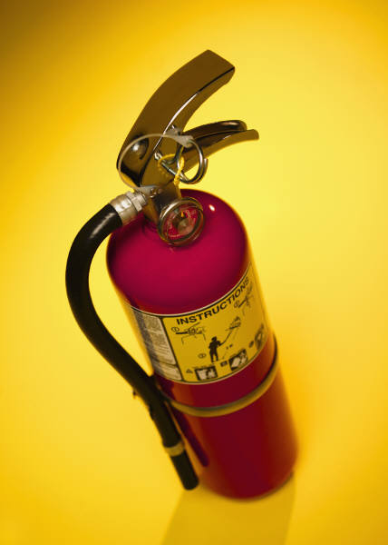


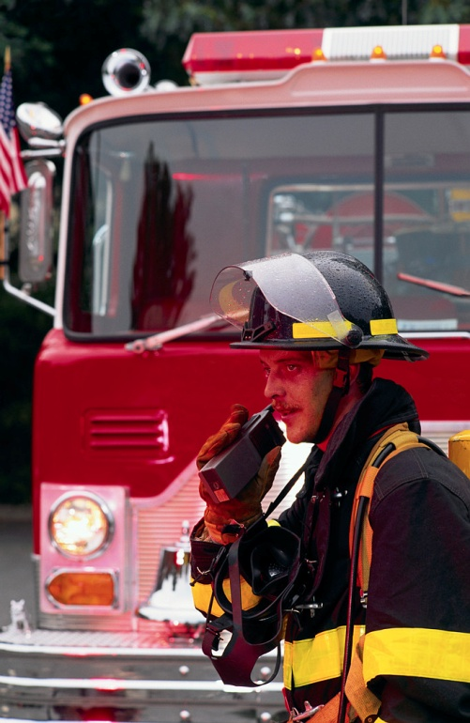
Note: This template is general in nature. If there are other emergency situations that you encounter in your location, include those as well. Each emergency action plan needs to be site specific. Examples of additional possible emergencies may include frequent threats of violence from consumers, close proximity to manufacturing facilities and being located near railroad lines.

Purpose:

The purpose of this Emergency Action Plan is to establish procedures for safely and effectively managing an emergency event for the [enter facility name]. All employees, supervisors, and managers are expected to follow the procedures outlined in this plan to ensure that employees and consumers are protected from any further harm during an emergency situation.

Authority:

California Code of Regulations, Title 8, Sections 3220, 3203, 6184, NFPA 1 Uniform Fire Code, section 10.9.

Scope:

This Emergency Action Plan covers those designated actions managers and employees must take to ensure employee and consumer safety from fire and other emergencies. This plan includes: emergency escape procedures and emergency escape route assignments; procedures for employees who have to stay to operate critical plant operations before they evacuate (if applicable); procedures to account for employees after emergency evacuation has been completed; rescue and medical duties for those employees who are to perform them; the preferred means of reporting fires and other emergencies; and individuals who can be contacted for further information about the plan.

- Responsibility

  - Person(s) responsible for emergency planning and information is/are:

[Name of person(s), Title]
[Contact Number]

  - Responsibilities of the Emergency Response Team

The goal of the Emergency Response Team is to assist in the orderly evacuation of employees and consumers from a building or area during an emergency or assist with shelter in place procedures if warranted. The duties of the Response Team are as follows:

    - Be familiar with the content of this plan.
    - Alert staff of emergency situations.
    - Ensure that staff and consumers are appropriately evacuating the facility or area based on the escape route assignments (see diagrams in attachment A).
    - Assist in the evacuation of consumers and staff with disabilities that preclude them from using elevators during emergency situations, or altering security, fire, and police personnel of the last known location of the individuals.
    - Perform medical duties as necessary to employees and consumers during emergency situations.
    - Extinguish small fires with the use of a fire extinguisher.
    - If instructed, account for all employees and consumers at the designated meeting location(s).

The list of the Primary and Secondary Responders is located in attachment B.

Note: The number of designated responders depends upon the size of the facility and the number of employees that work at that location. Larger facilities should have at least two responders per floor and at least one alternate. Smaller facilities can get by with one responder and one alternate.

Be sure to delete all notes inserted in this document!

  - Training

Emergency Response Team members will be trained and made aware of their duties so that they can assist in the safe and orderly emergency evacuation of employees. They shall be made aware of their responsibilities under this plan:

    - Initially when the plan is developed;
    - Whenever the employee’s responsibility under the plan changes, and
    - Whenever the plan is changed

  - Responsibilities of the Employees

The success of this Emergency Action Plan in times of emergencies hinges on employees knowing the procedures outlined in this plan and acting upon them in an appropriate manner.

Before an emergency, employees shall:

    - Become familiar with the contents of this plan to include who to report emergencies to, the assigned evacuation routes for the facility, and the designated meeting locations.
    - Actively participate in emergency drills and treat them as if they are real.

During an emergency:

- Assist an Emergency Response Team member if asked.
- Listen and wait for directions on how and when to evacuate the facility from emergency response team members, security, police, or fire personnel.
- Report any emergencies such as a bomb threat or threats of violence to your supervisor first and immediately.
- Follow the assigned escape route procedures to avoid crowding at the exits.
- Report immediately to your designated meeting location upon evacuating the facility. Do not take any side trips.
- Never go back into the facility to retrieve personal belongings.

- Reporting Emergencies

A. Report fire or other emergencies immediately, first to your supervisor, then to the responsible person(s) listed above. When warranted, call 911 (9-911 if in a County facility). Be prepared to provide the responder with the nature and location of the emergency. Our address is:

[Enter facility name]
[Enter facility address]
[Enter major cross streets]
[Enter facility phone number]

The Fresno County Security division shall also be contacted by calling the radio pager at (9) 452-7102 to advise them of the situation and for further assistance.

III. Employee Alarm Systems

The employee alarm system for this facility provides warning so that employees can escape safely from the workplace or the immediate work area.

The employee alarm system that has been established for this facility is as follows:

[Insert primary method of how all employees in the facility are notified of an emergency]

Note: Methods include but are not limited to: manual pull box alarms, public address systems, radio or telephones. If phones are used as a primary means of reporting, telephone numbers shall be conspicuously posted nearby.

[Insert procedures for sounding emergency alarms in the workplace]

IV. Evacuation Route and Assembly Area Map/First Aid Kits

  - Evacuation Routes and Maps

The evacuation routes and assembly area maps are posted by every main exit. Employees are to become familiar with all evacuation routes and their assembly point. See attachment A for evacuation maps for each floor(s) of this facility.

  - Location of First Aid Kits

As noted on the evacuation maps, the First Aid Kits are located [enter locations of first aid kits].

  - Designated Meeting Locations

Once employees have evacuated the facility, they must meet [enter location(s) where employees are required to meet] to check in with the [enter either first responder or supervisor] who will be accounting for individuals. Those employees who do not show up to the designated meeting location will be presumed to still be in the building and fire and police personnel shall be notified of their absence immediately.

Note: Attach a map of the facility and surrounding areas where employees are required to meet if necessary.

  - Procedures for Critical Plant Operations

The operation of this facility does not require individuals to block, isolate, or secure contents that may result in further harm to the occupants of the facility. Therefore procedures are not necessary for those who may need to operate critical plant operations during an evacuation.

Note: If there are operations that need to be taken care of during an evacuation that may create harm to the occupants of the facility and or to fire and rescue personnel if not addressed immediately, procedures for those who are required to stay behind to address these issues need to be developed.

- Fire Emergency Procedures

  - Remove anyone in immediate danger.
  - Once an employee is alerted to the fire danger, he/she will go to the nearest exit, activate the fire alarm (if present), exit the building according to the emergency action plan, and proceed directly to the designated assembly point.
  - Confine the fire to the room/area by closing the door to the area where the fire is located and by ensuring all doors leading to the main hallways are closed.
  - Attempt to extinguish the fire only if you have received training on the use of portable fire extinguishers, the fire is in its beginning stage, and it can be extinguished safely.
  - Disabled and non-ambulatory (unable to walk personnel) should request assistance from those nearest to them. Advise the Fire Department or Security of personnel trapped who may require assistance to evacuate.

- Earthquake Emergency Procedures

  - If you are indoors, stay there. Take shelter under a desk, table, or in a doorway. If you cannot get under something sturdy or stand in a doorway, get on your hands and knees and cover your head with your hands and arms.
  - [If you are in a high-rise building, stay away from windows, outside walls, light fixtures, filing cabinets and bookshelves. Do not attempt to use the elevators.]
  - If you are outdoors, go to an open area away from trees, buildings, walls, roadways and power lines.
  - If the building is evacuated, do not return until authorized.
  - Beware of potential dangers after an earthquake such as escaping gas, unstable building structures, electrical hazards, etc. Also beware of aftershocks.

- Evacuation of the Disabled

(Note: If in a single-story building, these procedures will need to be modified)

  - Persons with a disability (including a short term disability) limiting them from using the stairs will congregate in the lobby area by the elevator where they will be assisted by either an Emergency Responder or law enforcement personnel.
  - In the event an emergency renders the elevator lobby unsafe or dangerous, an Emergency Responder will assist or carry the disabled person down one or more floors for pick-up and relocation.
  - If assistance is not immediately available, disabled persons should stay in the exit corridor or at the top of the stairway or landing. An Emergency Responder will advise Security and Fire Department personnel of the location of the disabled person(s) in the event all other actions fail.

A list of employees who will need assistance in the event of an emergency is included in attachment C.

- Serious Injury

  - Check the scene and the victim to determine the danger potential and the extent of the injury. Do not move a seriously injured victim unless there is an immediate danger such as fire, flood, or poisonous gas. If you must move the victim, do it as quickly and carefully as possible. If there is no immediate danger, do not move the victim and advise the bystanders the victim is not to be moved.
  - Call 911 (9-911 if in a County facility) immediately if the victim is unconscious. Additionally, you should call for an ambulance if the victim has trouble breathing or is breathing in a strange way; has pressure or pain in the chest or abdomen; is bleeding severely; has slurred speech; appears to have been poisoned; has injuries to the head, neck, or back; or has possible broken bones.
  - Keep the victim calm and as comfortable as possible. Administer CPR or First Aid if you have been trained in those areas (A list of these employees is included at the end of this document). A First Aid kit should be used and precautions should be taken to minimize exposure to blood and other bodily fluids. Remain with the victim until emergency services personnel and Security arrive.

- Hazardous Materials

  - A hazardous material is a substance that presents a physical or health hazard. A health hazard refers to a substance for which there is significant evidence that health effects may occur for exposed employees.
  - A Material Safety Data Sheet (MSDS) is required for all hazardous substances in use within the department. Employees will be provided with training on the safe use of all chemicals they will be exposed to.
  - In the event of a hazardous material emergency:
    - Evacuate the area, securing access to the area when possible.
    - Immediately call 911 (9-911 if in a County facility) and inform the operator of the emergency. Provide as much information as possible to the operator and refer to the MSDS.
    - If safe, remain in the immediate area and call Security at 488-6785.
D. The list of chemicals regularly used in this facility are located [enter location of the list]. The MSDS binder is located [enter location of the MSDS binder].

- Bomb Threats

  - If you receive a bomb threat or discover a possible bomb or suspicious object(s), immediately notify your supervisor, Sheriff’s Dispatch at 488-3111, and Security at 488-6785 or the Security radio pager at (9) 452-7102 and wait for Security to answer. The supervisor shall immediately notify the department head of the situation.
  - In the event of a bomb threat by telephone:
    - Get someone’s attention and convey the nature of the call. Have them make the above notifications.
    - Get as much information as possible from the caller. Ask the following questions:
      - Where is the bomb?
      - When is it going to explode?
      - What does it look like?
      - What kind of bomb is it?
      - What is the person’s name or organization?
    - Record the following information:
      - Date and time of call
      - Exact words of caller
      - Age, sex, adult, or child
      - Any speech pattern or accent
      - Background noises
  - For bomb threats by mail or for suspicious objects discovered:
    - Do not handle the letter, envelope, or package any further.
    - Immediately notify Sheriff’s Dispatch at 488-3111.
    - Notify Security at 488-6785 or call the Security radio pager at (9) 452-7102.
    - Notify your immediate supervisor or department head.
    - Evacuate the immediate area if instructed to do so.

Attachments:

Attachment A- Flow chart of building with 1st Aid kit and fire extinguisher locations

Attachment B- First Responder List

Attachment C- List of disabled employees

Attachment A- Flow chart of building with 1st Aid kit and fire extinguisher locations

Note: Sample of an effective floor plan with designated escape routes. Delete and insert copies of your facilities escape routes. Directional arrows, locations of fire extinguishers and first aid kits should be included. Also include the location of where the individuals are viewing the layout of the facility.
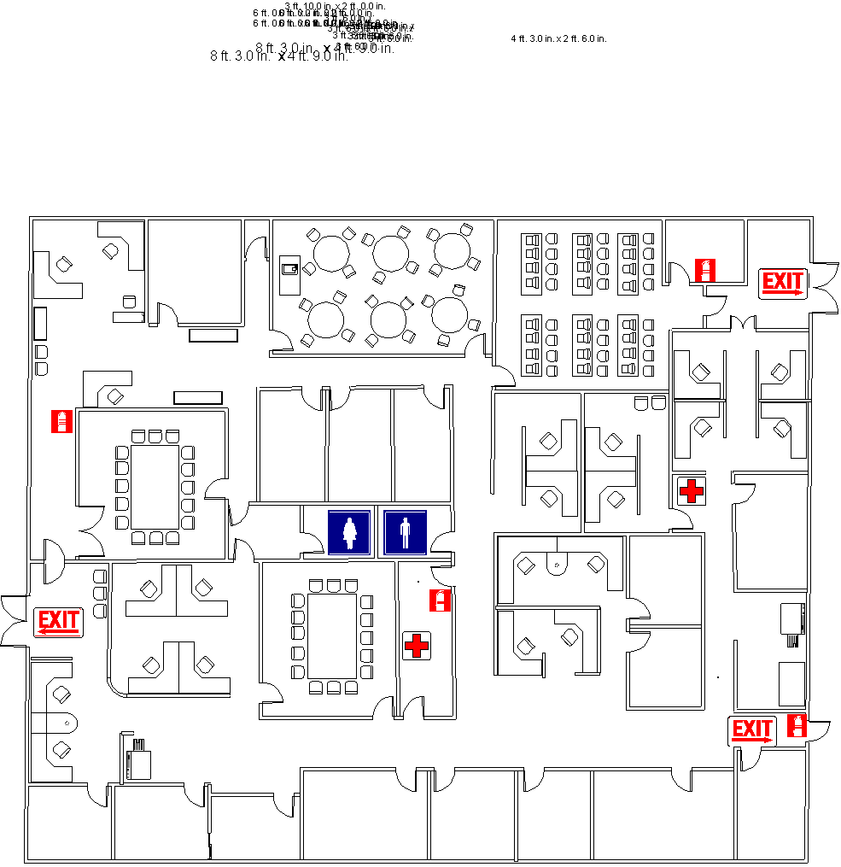

You are here

Attachment B- First Responder List

[Department Name, Location] Emergency Responder List
As of [enter date]

Floor# | Leader | Stop# | Phone | Alternate 1 | Stop# | Phone | Alternate 2 | Stop# | Phone

Attachment C- List of Disabled Employees

[Enter building name] Disabled List

[Revised Date]

Floor # | Location/Area | Name | Phone | Name | Phone | Name | Phone | Name | Phone

